

FINAL YEAR PROJECT REPORT

Project Code

AI-based active and social learning

Nicholas Koh En Jian (U1622054A)

Supervised by: Dr. Althea Liang Examined by: Zinovi Rabinovich (Asst Prof)

School of Computer Science and Engineering (SCSE) 2020



Project Code

AI-based active and social learning

Submitted in Partial Fulfilment of the Requirement for the Degree of Bachelor of Computer Science of the Nanyang Technological University

By

Nicholas Koh En Jian (U1622054A)

School of Computer Science and Engineering (SCSE) 2020

# Abstract

Learning Management System (LMS) is a platform which aids schools in delivery of course content while also tracking and documenting student’s progress in a course. Many schools employ the use of a LMS to facilitate learning for students attending. Nanyang Technological University, for example, uses Blackboard which is one of many LMS out there that allows a smooth delivery of course materials to students and serves as a convenient tool for the teaching body and students to exchange information/ feedback.

LMS aims to provide access to educational information easily, track a learner’s progress while also making it easier for educators to upload relevant announcements/ learning materials efficiently. LMS serves as a bridge between the school and the student in the form of information dissemination and feedback through the conducting of quizzes/ assignments on LMS platforms.

LMS also aims to engage students in a more proactive approach into their own learning, promoting students to take on a more active role in their own learning. And therefore, in this report, a discussion of how an LMS can provide a platform to facilitate active learning will be provided. An analysis of a few LMS will be evaluated in terms of whether they provide a good platform to engage students in active learning. There will also be a discussion of how LMS can be improved with the use of social media and analytics to actively track the progress of students and provide help to students where needed based on the use of these new features.

# Acknowledgements

I would like to offer my gratitude to my supervisor, Dr Althea Liang and PhD candidate Nick Zhang Shi Hui for their patience, guidance, encouragement, and critical critiques every step of the way for this Final Year Project (FYP). It would not have been possible without their help.

I am privileged to have their help through the entire process of my project to make sure that I am in the right direction and did not fall behind the project schedule. Thank you for explaining everything in detail and taking your time to help me even during this difficult time of the ongoing pandemic.

Table of Contents

Abstract I

Acknowledgements II

List Of Figures V

List of Tables VII

1. Introduction 1
   1. Background 1
   2. Purpose and Scope 2
   3. Organisation 2
   4. Project Schedule 3
2. Literature Review 4
   1. Active Learning 4
   2. Social Media in active learning 5
   3. Metric used to evaluate active learning 6
   4. Learning Management System 6
3. Technologies used 7
   1. Front End 7
   2. Back End 9
4. Analytics in LMS 10
   1. Web Log Analytics 10
   2. Life Cycle Analysis 10
   3. Learning Progression Analysis 12
5. Data Clustering and Filtering 18
   1. Content Based Filtering 18
   2. Collaborative Filtering 20
   3. Page Rank 21
   4. Markov Clustering 23
   5. K- Means 24
6. Proposed Learning Management System (LMS) 25
   1. Proposed Features 25
   2. Proposed Learning Management System 26
      1. Student View 28
      2. Faculty View 35
      3. Admin View 38
7. Conclusion 40
8. References 41

# List Of Figures

Figure 1: Global monitoring of school closures caused by Covid-19 in February (Unesco, 2020) 1

Figure 2: Global monitoring of school closures caused by Covid-19 in April (Unesco, 2020) 7

Figure 3: Screenshot of Moodle Page 15

Figure 4: Screenshot of a Blackboard page 15

Figure 5: Real Vs Virtual DOMs 16

Figure 6: Equation used in page rank 24

Figure 7: Screenshot of Blackboard learn front page (taken from Blackboard Learn) 26

Figure 8: Screenshot of Blackboard learn front page (taken from Blackboard Learn) 27

Figure 9: Screenshot of LMS Login page 29

Figure 10: Screenshot of student interest list 30

Figure 11: Screenshot of enrolled classes 30

Figure 12: Screenshot of lectures page 31

Figure 13: Screenshot of forum discussion page 32

Figure 14: Screenshot of Assignments Page 32

Figure 15: Screenshot of Quizzes Page 33

Figure 16: Screenshot of Course Material Page 33

Figure 17: Screenshot of deployed Facebook Messenger 34

Figure 18: Screenshot of Create class page 34

Figure 19: Screenshot of Class List 35

Figure 20: Screenshot of Enrolled students 36

Figure 21: Screenshot of analytics on LMS 37

Figure 22: Screenshot of Progress Page 37

Figure 23: Screenshot of a typical page for adding materials for a faculty member 38

Figure 24: Screenshot of admin dashboard 39

Figure 25: Screenshot of interests list 40

Figure 26: Screenshot of create “Create Teachers” page 40

Figure 27: Screenshot of clustering results after performing k-means 41

Figure 28: Graph result of initial Markov Clustering 41

# List of Tables

Table 1: Project Schedule 10

# Introduction

## Background

2020 was the year the world was hit with a previously unknown virus which led to World Health Organization declaring it a global Pandemic on 11th March 2020 (Straits Times,2020). This led to the lockdown of many businesses and schools to curb the spread of the virus. Schools have shifted their teaching online instead of conducting face-to-face classes to minimize social contact and curb the spread of the virus as it is speculated that community transmission could happen in dense social network like those in a school classroom (Sociological Science, 2020)

Figure 1 and 2 below compares the change in the numbers of affected learners in the world. Figure 1 shows that an estimated 999,014 learners were affected, with 0.1% of them engaging in online learning. The numbers grew drastically in a month after WHO declared Covid-19 a pandemic as shown in Figure 2. More than 1 billion learners were affected and 84.5% of them are all engaged in some form of online learning as schools started closing to limit social contact.

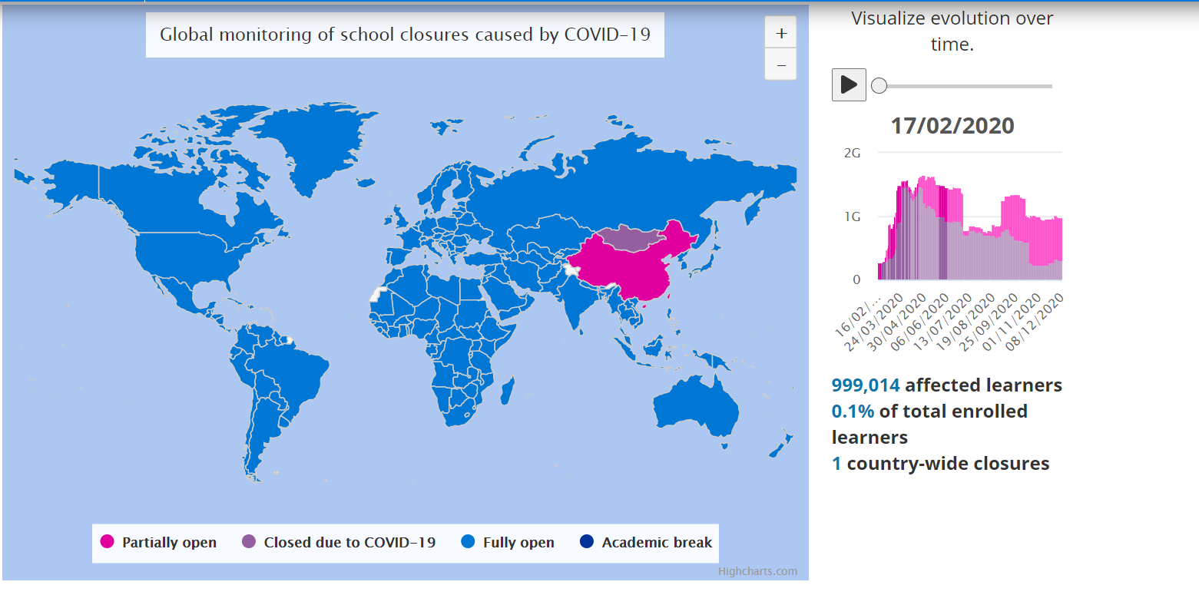

Figure 1: Global monitoring of school closures caused by Covid-19 in February   
Image retrieved on 09/12/2020 from (UNESCO, 2020)

Figure 2: Global monitoring of school closures caused by Covid-19 in April   
Image retrieved on 09/12/2020 from (UNESCO, 2020)

The use of technology allows for room to cater to the different learning styles of students. As students can go back on their own at any time to relook at any given course material. Therefore, students are able to learn at a comfortable pace on their own and as a result, an e-learning experience enhances the rate of retention in students by an approximate 25-60% (Urdan, 2000, p.6)

With the increase in shift towards online learning, there is a need to focus on the benefits of the use of LMS in education and how it can provide a platform to engage students actively in their own learning and provide a means for teachers to keep track of their progress.  
In this project, a LMS which aims to keep students and faculty more connected using social media will be implemented. An added feature of analytics and data clustering will provide the means for educators to keep track of student’s progress on the platform and administer help to students who need it more effectively.

## Purpose and Scope

To implement an effective LMS that meets the criteria of engaging students in active learning, the report will aim to discuss the definition of active learning and how it might be implemented in the new LMS. The report will also be discussing the different existing LMS in use and doing a comparison between them to see how they might or might not facilitate active learning.

Lastly, we need to determine a method for educators to determine the students who need help using clustering in hopes to effectively render help where needed given the situation that face-to-face classes might not be applicable.

## Organization

In the next chapter, it provides a literature review relevant to this report it will discuss what active learning is and provide an insight of what a learning management system can provide. Chapter 3 focuses on explaining more on the technologies used for the project.

Chapter 4 emphasizes on discussing analytics used in the system and how clustering can help improve feedback on the use of LMS by the students.

Chapter 5 will be discussing on the system created and what it can do.

The last chapter will thus provide a conclusion and future work that can be carried out.

## Project Schedule

|  |  |
| --- | --- |
| Milestones | Completion Timeframe |
| Briefing and discussion with the supervisor | 23 Aug 2020 |
| Project Plan Document | 30 Aug 2020 |
| Literature Review | 3 Sept 2020 |
| Design Review | 14 Sept 2020 |
| Coding for the design | 30 Oct 2020 |
| Testing of algorithm | 7 Nov 2020 |
| Improving of algorithm | 10 Nov 2020 |
| Evaluation of the design and codes | 15 Nov 2020 |
| Submission of Final Report | 08 Dec 2020 |
| Submission of Amended Final Report | 10 Dec 2020 |
| Oral Presentation | 15 Dec 2020 |

Table 1: Project Schedule

# Literature Review

To gain understanding on what we are building and what we aim to achieve (specifically a LMS which facilitates active learning), literature research will be done and presented in this section

## Active Learning

Active learning is defined as “any approach to instruction in which all students are asked to engage in the learning process” (Active Learning, n.d). It stands in contrast with the more traditional modes of instructions in schools where students passively receive knowledge from their educators.

Active learning usually involves students participating in discussion, problem solving, case studies, role- playing and various methods that can be used as a mode of instruction to actively engage learners with course content. In active learning, the responsibility falls on the learner to reinforce learning on their own instead of taking a passive role traditionally like listening to lectures. Active learning also reinforces knowledge learnt in class through the application of knowledge taught and engages students in deep thinking.

(What is Active Learning, n.d)

Active learning is based on constructivism which is a learning theory that establish the fact that students use their prior knowledge to form their own understanding towards a topic. This would mean focusing more on a learner’s knowledge construction rather than transmission. Active learning is found to be the most effective with knowledge construction through collaboration. It is a more hands-on approach that involves someone engaging in activities that gets them to think about the concept behind the application the necessary knowledge. (Active Learning Activities, 2020)

It builds understanding behind concepts learnt rather than on the memory of facts; it encourages students to apply what they learn to solve different problems.

Listed below are a few active learning activities that might be incorporated into the Learning Management System (LMS):

1. Learning by teaching
2. Small group discussions
3. Debates
4. Think-Pair-Share
5. Sticky- note Clustering
6. Dotmocracy
7. Cumulative Brainstorming
8. Crowdsourcing
9. Snowballing

## Social Media in active learning

An investigation in 2007 discovered that the users of Facebook by college students had an average age of 20.4 (n = 69) and found that more than half of the users accessed Facebook every day. 82% of the people who accessed Facebook everyday updated their profiles on a daily (Dwyer, Hiltz, Passerini, 2007). It was also found that university students (n = 909) used Facebook mainly for documenting their university experience, exchange of practical and academic information, and displaying supplication or disengagement. (Selwyn N., 2009) In another study in 2009, it was reported that the majority of the surveyed university students (n = 213) used Facebook for social reasons, and about 10% used it for discussing academic work. However, less than 1% used it for contact with academic staff. (Madge, C., Meek, J., Wellens, J. & Hooley, T. ,2009)

However, social media can potentially be a useful tool in helping students engage in active learning. Students can make use of social media to find out more information about a topic. The use of hashtags in Facebook, twitter or Instagram helps to easily filter out content by topics interesting to students. Students can directly watch videos from YouTube to view videos about topics that are interesting to them. The amount of information available on social media is vast and the way it is presented makes it more easily absorbed by students. Students participate directly in their own learning when they source for more information or content about a certain topic. (Using Social Media for Learning,2020)

The use of social media as a platform for learning through information sharing boosts engagement and interaction between students which in turn could reinforce their knowledge of a topic.

Furthermore, based on the psychology behind social media sharing, if students know beforehand that what they wrote would be seen and discussed, they might put in more effort and thought into the post. Positive social media feedback has been linked to self-esteem and positive feedback usually lead to more posts and more sharing. (The Psychology of Social Media,2020)

Examples of the use of social media in active learning:

* Facebook
  + Social networking site where users posts comments, share photos and post links to articles or any other content available online, chat live or watch videos.
  + Useful for active learning as information sharing between user is easy and convenient
  + As a result, promotes discussion and interaction among users
  + Content filtering algorithms ensure that relevant content reaches intended users which can be useful for learning reinforcement.
  + Live chats being able to host a small group which can be useful in hosting small group discussions over the internet.
* Pinterest for Student Collaboration
  + “Pinterest is a visual discovery engine for finding ideas” (Pinterest)
  + Students can use Pinterest to pin up inspirations for their next project, be up to date with the latest technologies which is especially important in the Engineering field.
  + Students can build on each other’s ideas or interests based on boards that are shared
  + Can be a useful tool to use in sticky-note clustering which is an active learning tool as Pinterest provide a visual depiction of student’s ideas
* YouTube for student engagement and learning
  + An American online video sharing platform which allows users to upload, view, rate, share, add to playlists, report, comment on videos, and subscribe to other users.
  + Can be a useful tool to use for activities like discussions, debates or think-pair-share
  + It can be used as a platform to deliver course materials students or for students to upload their presentations to be seen and discussed by other students as well.
  + Students can use YouTube to explore an array of topics through videos which is helpful in reinforcing knowledge or to explore new topics which were previously unknown to students

## Metrics used to evaluate active learning

(Taylor, J. E., & Ku, H.-Y. (2011) proposed a method for measuring active learning in class for computer-based courses.

A course is split into a percentage of the duration learners spend in instructional events designed for active cognitive engagement:

* Attend
* Organize
* Recall
* Practice
* Interact
* Apply
* Explore

This percentage can be used to represent the active learning index which shows how much a learner spends on active learning in a subject. (Van Amburgh JA, Devlin JW, Kirwin JL, 2007) discussed “The Active-Learning Inventory Tool” which uses qualitative and quantitative information to capture the amount and type of active learning in the classroom that has been evaluated for validity and reliability.

It helps to correctly identify gaps between faculty perceptions of classroom activities and actual usage of active learning based on the 3 key components that needs to be observed (context, engagement and reflection) to determine active learning in class.

It provides qualitative feedback on

* Faculty approach towards a curriculum
* Quality of classroom environment during the curriculum
* Overall atmosphere

## Learning Management System

There are a range of open-source learning management systems online and each of them have their own features and functions and this section aims to further discuss the similarities and differences between each of them and see which are the features we could implement too.

**Moodle**

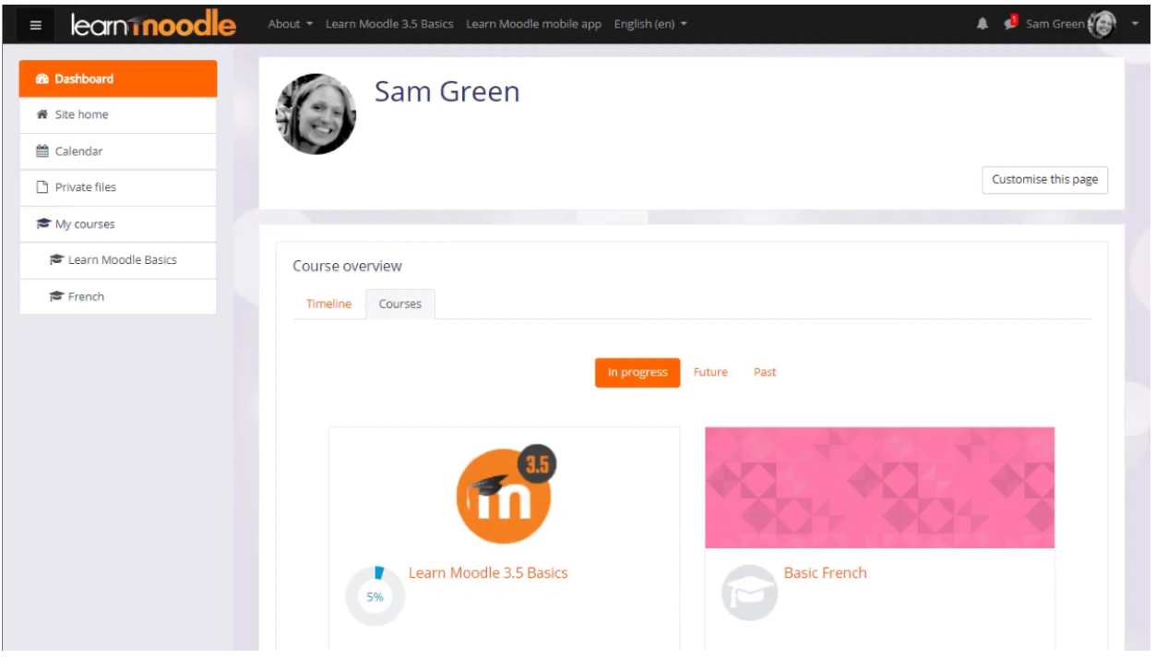

Figure 3: Screenshot of Moodle page (Image taken from <https://docs.moodle.org/310/en/About_Moodle>)

Moodle is a learning platform aimed to provide schools with a single robust, secure, and integrated system to create a personalized space for learning.

Moodle is used by over 60% of institute of higher education like Monash University, Louisiana State University, etc. Features of Moodle include:

* Online Exams
* Single sign-on with existing systems
* Active learning
* Online grading
* Online and offline learning

**Blackboard**

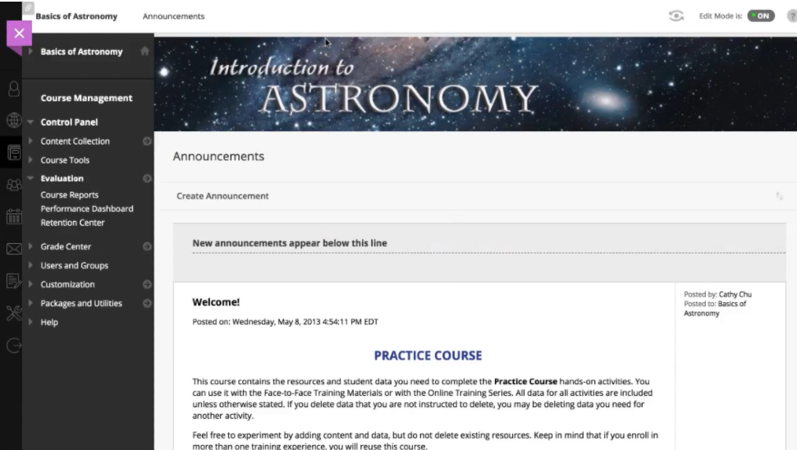

Figure 4: Screenshot of a Blackboard page

Being one of the more popular LMS on the internet, Blackboard is being used by many universities globally including Nanyang Technological University. Blackboard offers both software-as-a-Service (SaaS) and a non-SaaS model.

Blackboard not only provides the core learning management features, it also provides powerful data analytics, collaboration tools and even web conferencing. Educators can efficiently disseminate information, course materials and track student progress.

Blackboard Learn features a more responsive and user-friendly interface for users. It comes with analytics that will allow for valuable insights to track the usage patterns on the interface. Blackboard also release Open LMS which is powered by Moodle which allows for customization of the interface.

# Technologies used

This section aims to discuss the technologies used to create a working LMS platform.

## Front-End

**Reactjs**

Reactjs is a declarative, efficient and flexible JavaScript library developed by Facebook for building interactive and dynamic user interfaces. It allows developers to build complex UIs using “components” which allows for a quicker and easier setup of webpages. It allows for building a dynamic UI with high performance. Some advantages include:

1. The use of virtual Document Object Model makes the user experience better and developer’s jobs faster.

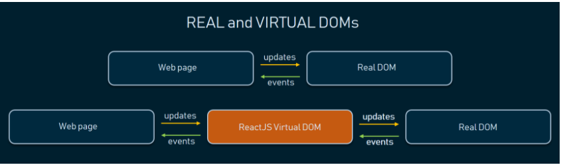

Figure 5: Real Vs Virtual DOMs Image taken from <https://www.altexsoft.com/blog/engineering/the-good-and-the-bad-of-reactjs-and-react-native/>

The use of DOM allows the update of even the smallest changes applied by the user and this does not affect other parts of the interface. This is only possible due to the segregation of components in React, coupled with a special data structure in the library. Therefore, updating webpages in React is fast, allowing the building of a very dynamic UI. Therefore, this allowed developers to work with UI-objects faster and use hot reloading, making programming a new webpage faster.

1. Reusable components

There are plenty of components available when a developer uses ReactJS to develop a web application. These components are reusable with their own logic and controls such that developers can use these components across multiple projects. The use of virtual DOMs to fill data in components also allowed faster development as changes in these components is only applied locally and not through the entire DOM. The management of components are also easier for developers as all react components are isolated and therefore allow for easier reuse as well.

1. Single Direction data Flow

Direct changes to the child components in React does not affect their parents as Facebook made ReactJS a view system. In traditional view-model system, modification to child elements may affect their parents. Therefore, by limiting ReactJS to only have downward dataflow, a developer just needs to modify an object’s state directly and apply updates. This makes managing and modifying components simpler as developers do not have to worry about how it will affect the other components.

**Python**

Python is a interpreted, object- oriented, high level programming language with dynamic semantics. Its high-level built-in data structures, combined with dynamic typing and binding, makes it very useful for rapid application development. This fits well into the requirements of this project as well given the shorter time frame. Python is simple, has easy syntax, emphasizes readability, and therefore reduces the cost of maintenance. Some advantages of Python include:

1. Ease of reading, learning, and writing

Being a high-level programming language, Python has an English like syntax. This makes it easier for people read and understand Python code.

1. Improved Productivity

Due to the shorter time frame given, this is important as being a relatively easier language to pick up, developers need not spend more time understanding the syntax or behavior of this programming language and can solely focus on solving the problem with python.

1. Dynamically Typed

Python automatically assigns the data type during execution. Therefore, a developer need not worry about declaring variables and their data types and can focus more on logic behind the codes.

1. Portability

A developer can run python anywhere on different platforms as long as the code does not feature any system-dependent features. This would be useful as the LMS will be running as a web application that might be run on a myriad of platforms in future.

## Backend

**Node.js**

Node.js is a packaged compilation of Google’s V8 JavaScript Engine, the libuv platform abstraction layer, and a core library. It aims to create real-time websites with push capabilities. Node.js uses non-blocking, event- driven I/O to remain light weight and efficient even with data-intensive real-time applications that run across distributed devices. Node.js is also useful in the application of this project as it allows developers to build fast, scalable network applications and is also capable of handling various simultaneous connections with high throughput, making it highly scalable. Some pros of using Node.js include:

1. Robust technology stack

Using Node.js, a developer automatically gets all the pros of a full JavaScript development like:

* Higher efficiency and overall development productivity
* Code sharing and reuse
* Speed and performance
* Easy knowledge sharing
* Availability of free tools

1. Scalable technology for microservices

Using Node.js for microservices architecture where the application logic is broken up into smaller modules, enables better flexibility and allows scaling in future. Therefore, it is easier to add more microservices should there be a need for additional features in the application without problem.

1. Seamless JSON support

Node.js can use JSON format for communication without having to convert between binary models. This is useful for this project as the application requires API calls from Facebook or a database for logins for example.

**MySQL**

MySQL is a database management system that is used to add, access and process data stored in a database. Some advantages of MySQL include:

1. Data security

MySQL provides strong data security to safeguard data through having secure connections, authentication services, fine-grained authorization and controls and data encryption. It is a relational database used by many web applications including Twitter and Facebook.

1. On-demand scalability

MySQL offers scalability to facilitate the management of deeply embedded apps. This is useful for the project as this means that it is able to handle the amount of data that usually comes with schools using a system.

1. High Performance

MySQL has a distinct storage-engine framework that facilitates system admins to configure MySQL database servers.

# Analytics in LMS

Analytics are important to help gain insights into a system or an organization and having a form of analytics in LMS can help schools/ lecturers to identify gaps in classes or identify weaker students that might need attention.  
  
Below are some of the more common analytics methods employed in LMS performance:

## Web Log Analytics

These highlights learning activity, logs visits to different sections of the system. Some indicators to include visit times, durations and number of visits, most/least viewed pages, and user authentication times, etc.  
  
Studies have shown the significance of community in an online learning environment. Rovai (2002c) defines community in online learning environments as:  
  
“… consisting of 2 components: feeling of connectedness among community members and commonality of learning expectations and goals…” Classroom community is strong when learners (a) can relate with their peers and instructors online (b) develop immediate communication norms that lowers social and psychological distance between people, (c) share common interest and values, (d) trust and help one another, (e) actively engage in 2-way communications, and (f) pursue common learning objectives (Rovai A., 2002)  
  
Therefore, mining data based on user’s usage pattern on the LMS can be a good indicator of the level of community fostered online ( based on, time spent on pages like forums or number of comments made, etc.).

## Life Cycle Analysis

Life-Cycle Analysis focuses more on individual students or their study groups (classes, majors, etc.). Its “scope of interest” includes the use of the resources across different study areas, technology adoption level and learners’ participation (learning activities, discussions, etc.). It is difficult to pass down technological knowledge at University level (for example) through a LMS as:

* 1. It is not easy for professors to support students of varying aptitude in a topic
  2. It is not easy to control instructive contents with respect to how motivated a student is or how much they already know and difficult for professors to provide beyond what was already uploaded.

Therefore, to resolve the aforementioned problems, there is a need to:

* Select the right instructive content for students
* Assess various student’s aptitude based on the topic
* Revise the uploaded content accordingly

(Hasegawa, Shinobu & Ochimizu, K.. ,2005)

The management of a student’s experience in a LMS is based on the life cycle synchronization ‘s model of education programs, educational materials, and the teacher’s level. To manage the environment component lifecycles, a software-tool complex is developed that synchronizes the educational content with training programs, the employer’s requirements and the training specialist’s levels. Therefore, using every step of the lifecycle of the LMS to better facilitate the dissemination of content to students, to better seek which stage of the life cycle is suitable to synchronize the educational content with the school’s/ industry’s standards to the students or to forecast the training trajectory with an assessment quality of what was being taught. All these could be done to better enhance the quality of learning for students using a LMS.

## 

## Learning Progression Analysis

Analyzing the growth of students with respect to their learning is an important factor in determining if what they are learning was fully understood by the student. This is especially so in the field of STEM education where the progression/ advancement of science within that past century made it such that STEM education needs to go beyond mere mastery. That is, taking science in practice for example, to explain what we observe in the natural world and using evidence to support hypotheses. This has propelled educators/ researchers to shift towards the stance where education should be coordinated and sequence over a long period of time(like over months of knowledge reinforcement) and should not be something that is taught over a few days or weeks.   
  
One area of Educational Testing Service (ETS) researchers is examining are the step by step approach of what students go through when learning a new concept or mastering a new skill. There has been a lot of research done in the learning progression towards maths, english, the arts and sciences.   
  
“Researchers are trying to assemble a body of progressions that offer likely paths to proficiency in a significant portion of the domains that are taught in school,” says Randy Bennett, who holds the Norman O. Frederiksen Chair in Assessment Innovation at ETS.  
  
This can be seen in (<https://www.ets.org/s/winsight/pdf/learning-progressions-sell-sheet.pdf>) where a student can make general judgments about ratios(level 1). Level two demonstrates progress to simple quantitative reasoning. By level three, the student can use multiplicative reasoning, and by level four, the student is able to flexibly select from a range of strategies to work with ratios.  
  
Educators can then use learning progression to better identify which students are lacking in which areas and therefore better instruct the appropriate interventions to help these students.

# Data Clustering and Filtering

## Content Based Filtering

There is a need for filtering of content on social media on Facebook due to the amount of content being generated each day (which is way more than what human brains can process.) So, how can they make sure that the right type of content reaches the right type of people and how social media can sieve through the noise (maybe generated through excessive notifications like those of your friend’s next achievement in candy crush). We will be looking into certain types of filtering used online to sort through all these noises and making sure the right content reaches the right people.

Content-based filtering recommends content like a user’s preference, based on their history online/ on social media or through explicit feedback from the user.

Learning model used for filtering does not require the data of other users as it uses the feedback from specific user to do the filtering.

Content based filtering is able to capture a “tailored” interest for the user and therefore able to recommend specific genres that might not be that popular to the general public. As the model provides recommendations based on user’s existing preferences, it is not useful in helping a user explore/expand their interests

Feature representation of content-based filtering is hand engineered to some extent and therefore it requires a lot of domain knowledge. For example, to recommend an app on google play store, information about what the app does, its category, user preference, all needs to be captured and recorded correctly to be able to recommend the correct type of apps to the user.

## Collaborative Filtering

Collaborative filtering Recommends content based on similarities between users and the content simultaneously. This model can recommend user A content based on interests of another user B who is categorized to have similar interests.

* + In an example of a movie recommender, training data involves a feedback matrix where:
    - Rows represent Users
    - Columns represent movies (in this case movies
  + Feedback falls into either criterion:
    - Explicit – a numerical rating of how much a user liked the movie
    - Implicit – a user is deemed interested if they watched the movie
  + Therefore, when a user visits a movie recommender page, the page should recommend movies based on
    - Similarity to movies the user has liked before
    - Movies that similar users liked
  + Advantages include:
    - No prior domain knowledge required as embeddings are automatically learned
    - Useful to help users discover new interests or meet new people based on similar interests.
  + Disadvantages include:

“Cold-Start problem” where the system cannot handle items that are just added into the system. A given (user, item) pair is used as a prediction to create the dot product of the corresponding embeddings. Therefore, new items which has not received feedback/ ratings might not be seen by the model during training and therefore this embedding cannot be created.

* 1. Page Rank

Page rank is a system that ranks webpages by giving each page a relative score of importance and authority by determining “how good” the links are and how many links are there.

Each link from a page to the other casts a so called “vote”, the weight of which depends on the weight of the pages that linked to it.

Page rank is also affected by something called the dampening factor which is the probability that any person on the site will stop clicking on links to another page. It is generally assumed to be 0.85.

The PageRank algorithm represents how likely someone who is randomly clicking on links will arrive at any page using a probability distribution.

The algorithm goes through several iterations to adjust the approximate PageRank values to be closer to the theoretical true value.

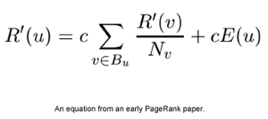Figure 6: Equation used in page rank

Image taken from <https://www.practicalecommerce.com/pagerank-what-is-it-and-how-do-you-calculate-it#:~:text=PageRank%20for%20a%20given%20page,page%20an%20initial%20PageRank%20score.&text=If%20I%20create%20two%20new,an%20initial%20PageRank%20of%201>)

## Markov Clustering (MCL)

MCL distinguishes different groups based on the usage patterns obtained from the LMS. The MCL algorithm is used to discover clusters in a graph. It is based on the notion that natural clusters in a graph have different edges between the members of each cluster and few across clusters. Once entering a cluster, a hypothetical random walker will have little chance to get out of the cluster. MCL simulates random flow within the whole graph and strengthens already strong flows while weakening already weak flows. The underlying cluster structure becomes more visible after several iterations of this process. Regions of graph with high flows that describe clusters are separated by boundaries with no flow.

The MCL simulates the random walks within a graph by two algebraic operations called expansion and inflation that are applied to a stochastic matrix (a square matrix where its columns are probability vectors that add up to 1. It is a matrix to describe the transition of a Markov Chain). The matrix representing the graph is used as input, and expansion and inflation are applied for many rounds until little or no changes are made in the matrix. The final matrix then represents the clustering of the graph nodes. Expansion refers to the power of a stochastic matrix using the normal matrix product. Inflation is the entry-wise Hadamard-Schur product combined with diagonal scaling and is responsible for both the strengthening and the weakening of the flow. The value of inflation controls the granularity of the clusters. (Valsamidis, Stavros & Kontogiannis, S. & Kazanidis, Ioannis & Theodosiou, Theodosios & Karakos, Alexandros. (2012))

Some points to take note:

* MCL scales well with increasing graph size.
* Works with either weighted or unweighted graphs
* Good clustering results
* Robust against noise in graph data
* Usually cannot find overlapping clusters
* Not suitable for clusters in large diameter

PageRank of a Webpage is defined by a Markov Chain.

## K- means clustering

K-means clustering is a non-hierarchical clustering method that is used to partition datasets in a way that “sum of the within- cluster variances are minimized. (Stanley D & Brusco, M.j., 2007) N number of objects/ datasets are being partitioned into k-number of partitions that is usually defined by the user. Usually, a well-defined k-value will result in a better clustering result where the datasets will not be too far from a cluster’s centroid. A centroid can either be a random datapoint in the defined space, or the user can define the points to be the centroid. Centroids that are well chosen can also result in better clustering results. K- means cluster works by taking the Euclidean distance between the centroid and the datasets and assigning each dataset to the centroid that it is the closest to. After the first round of assignment, the average value of the datasets is calculated, and this will be set as the new centroid. Datasets will be compared to the new centroid and reassigned if need. This process will be repeated until either a defined number of iterations has passed or if the calculation of the means of the values of the data in the cluster does not change the value of the centroid anymore. (Dr Michael, J., n.d)

Advantages of K-means clustering include:

* Easy to implement
* Scales with large data set
* Guarantees convergence
  + Data will belong to some cluster
* Choosing the right “K” value results in better clustering results

# Proposed Learning Management System (LMS)

## Proposed Features

**Features of LMS**

1. Registration with Facebook Accounts - Student must be able to register an account with the LMS using their Facebook own accounts
   * Despite using their own Facebook accounts for registration, prompt students for their faculty and Student ID number during registration to make sure that the student is indeed a student with the university. (The university’s student ID number goes by the format UxxxxxxxX, where ‘x’ is any number from 0-9 and ‘X’ is any letters from A-Z.)
2. Login with Facebook accounts - Registered student must be able to login to the LMS with their Facebook accounts after registration.
3. Dashboard on the main page of the LMS – System should allow students to view all important information regarding their classes/ about the LMS
   * The dashboard should also be able to show any announcements posted by the lecturer

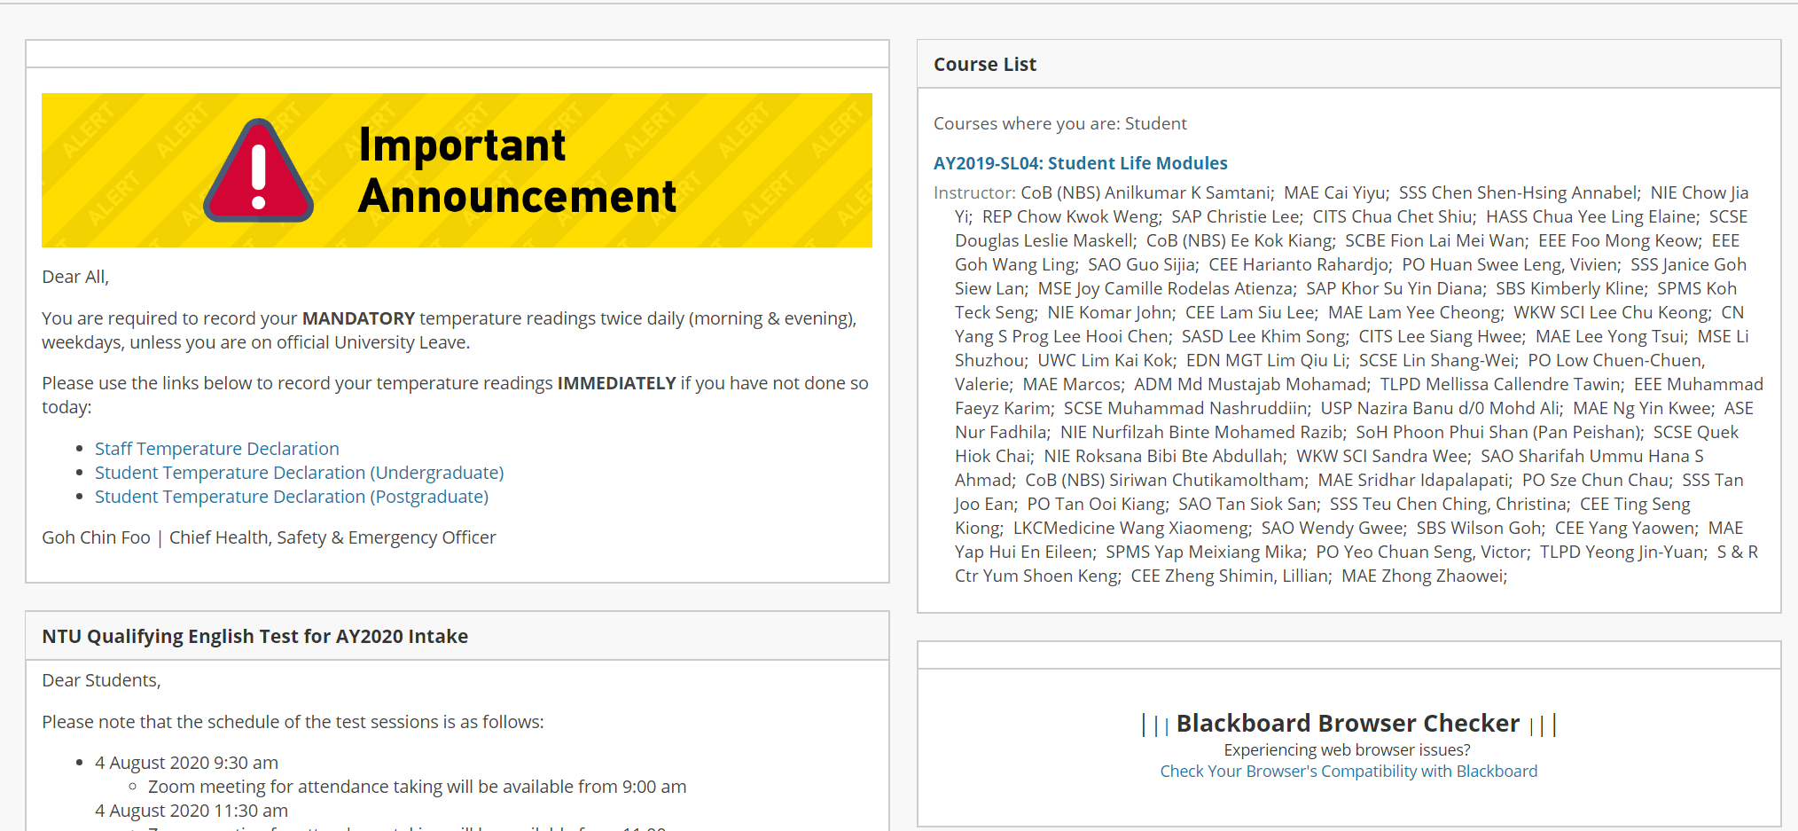

Figure 7: Screenshot of Blackboard learn front page (taken from Blackboard Learn)

1. Administrator accounts (the person who is managing the LMS from day to day as of now)
   * System must allow the admin to manually add the names of lecturers who want to conduct classes through this LMS
   * System must allow admin to view overall page usage history of the system
   * System must allow admin to generate a clustering report for better analytics
   * System must allow admin to add an interest page for students to choose from
2. Professor/lecturer accounts
   * System must allow the professor to create classes
   * System must allow professor to create announcements
   * System must allow professor to create quizzes
   * System must allow professor to add course materials
   * System must allow professor to add course materials
   * System must allow professor to view student quiz/assignment submission
   * System must allow professor to download student assignments for grading
   * System must allow professors to post forum posts
   * System should verify professor credentials (probably through staff ID)
   * System must allow professors to login through their facebook accounts
3. Student accounts
   * System must allow the students to view classes
   * System must allow students to view announcements
   * System must allow students to view quizzes
   * System must allow students to submit quizzes
   * System must allow students to view course materials
   * System must allow students to download course materials
   * System must allow students to view course materials
   * System must allow students to download course materials
   * System must allow students to submit quiz/assignment
   * System must allow students to download student assignments
   * System must allow students to submit student assignments
   * System should allow students to choose their interest in the interest page
   * System should verify students’ credentials (probably through student ID)
   * System must allow students to login through their Facebook accounts

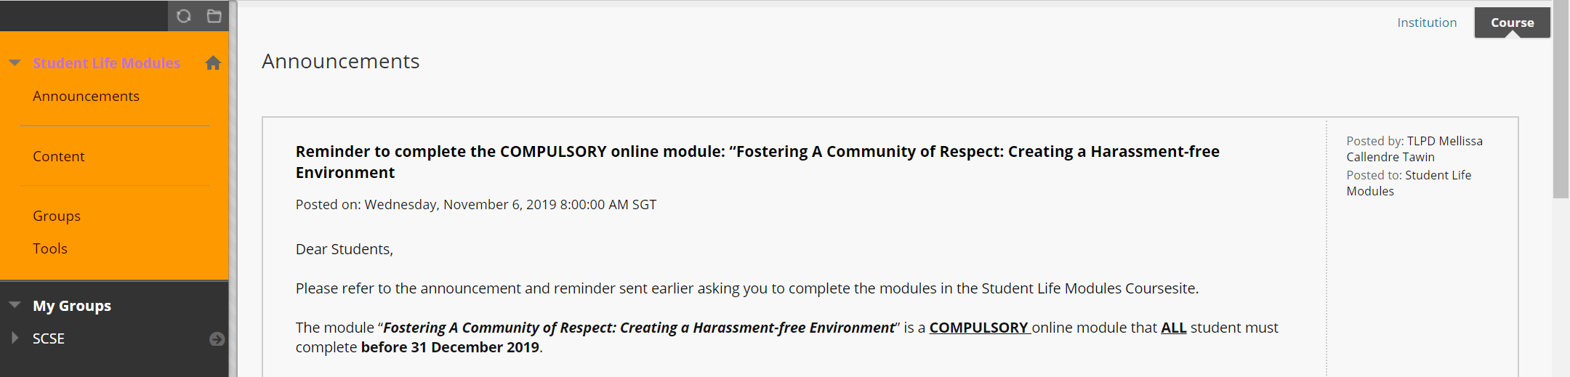

Figure 8: Screenshot of Blackboard Learn (Taken from Blackboard Learn)

Students should be brought to the respective course page after clicking on a course on the main page. The course page should contain links to bring students to subsequent pages (that are all listed below) that are specific to this course.

1. Quizzes Page – This is the page students go to do their quizzes
   * System should allow students to check the number of attempts they have left
   * System should allow students to view their scores
   * System must record the scores of the students for lecturers to collate
   * System must allow professors to view student scores
2. Assignment Page - Where students can view and submit their assignments
   * System must record the scores submitted by professors
   * System must be able to show the scores to students
3. Contents Page – Where students can view course materials and access the recorded lectures.
   * There should be an option for lecturers here to upload a video recording of their lectures which students can access
   * Lecturers should be able to upload course materials (slides/ word docs) as materials for the lessons
   * Students should be able to access and download the course materials from this page
   * Students should be able to view the recorded lecture that was uploaded on the page too (there should be a link to access the uploaded recorded lecture)

## Proposed Learning Management System

This section shows the different pages of the new LMS and possibly discusses the functions of certain features

## Student View

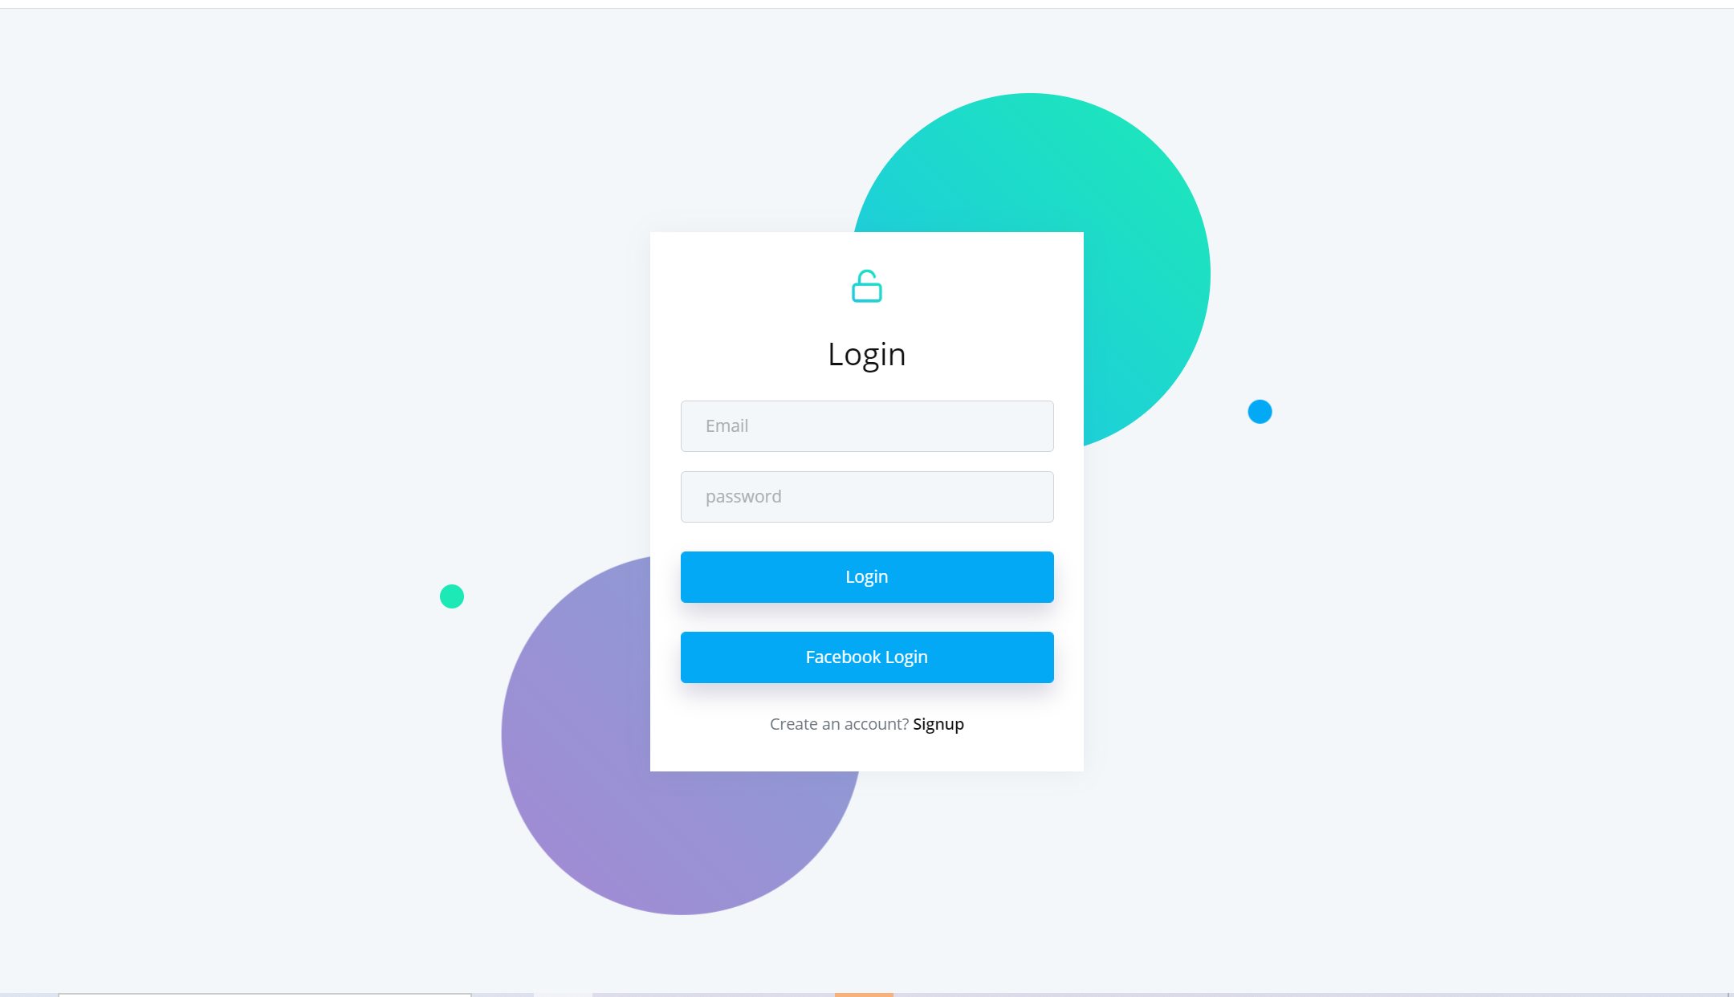

Figure 9: Screenshot of LMS Login page

Figure 9 shows a screenshot of the login page for the new LMS. It has been added with a feature that allows student/faculty to login directly to the LMS using their own Facebook accounts. This is done so by calling the Facebook login API provided by Facebook to implement the login with the authentication and verification of their Facebook details. Facebook handles the security concerning the accounts and the LMS does not store any information pertaining to the user’s Facebook accounts. Therefore, users need not worry about their Facebook credentials being leaked.

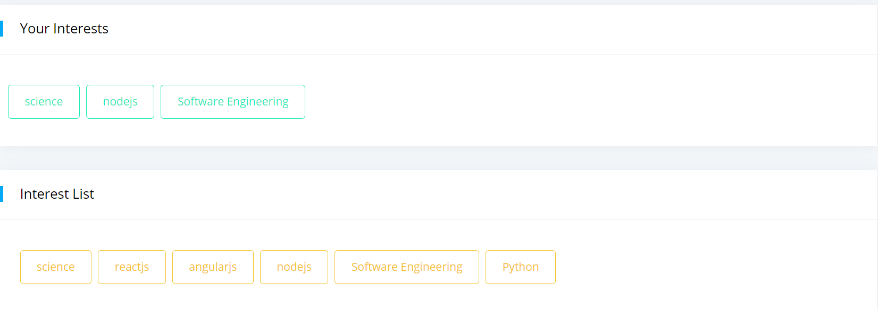

Figure 10: Screenshot of student interest list

Figure 10 shows the interest list that can be accessed by students to select their interests in the topics available. Students can choose up to 3 interests and this will serve as a set of data that can be used to recommend relevant pages to students through clustering.

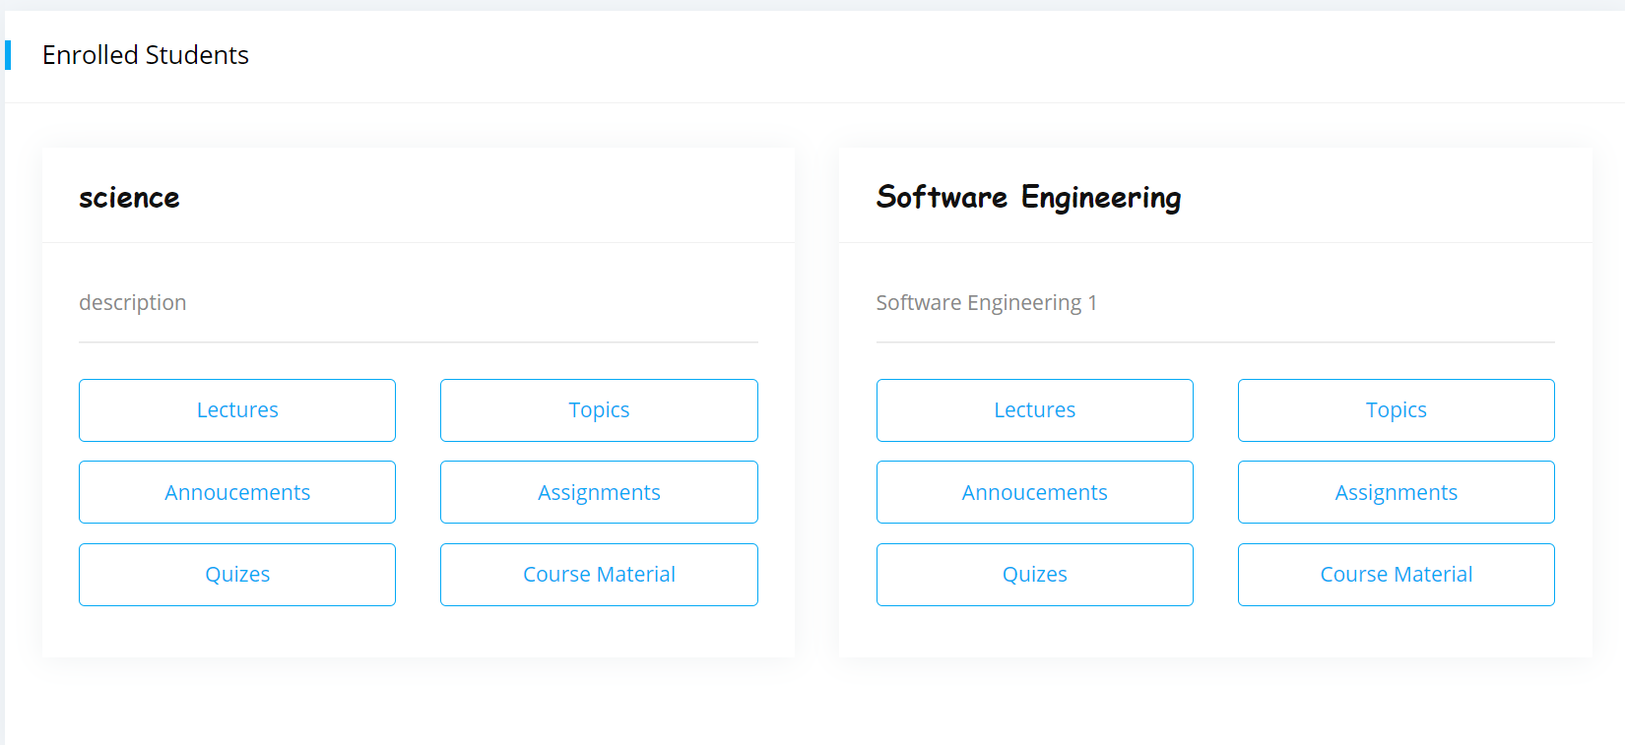Figure 11: Screenshot of enrolled classes

Figure 11 shows the list of classes that the student has enrolled in. Students are able to access lectures, view course materials, submit assignments, attempt quizzes or join a forum discussion through this page.

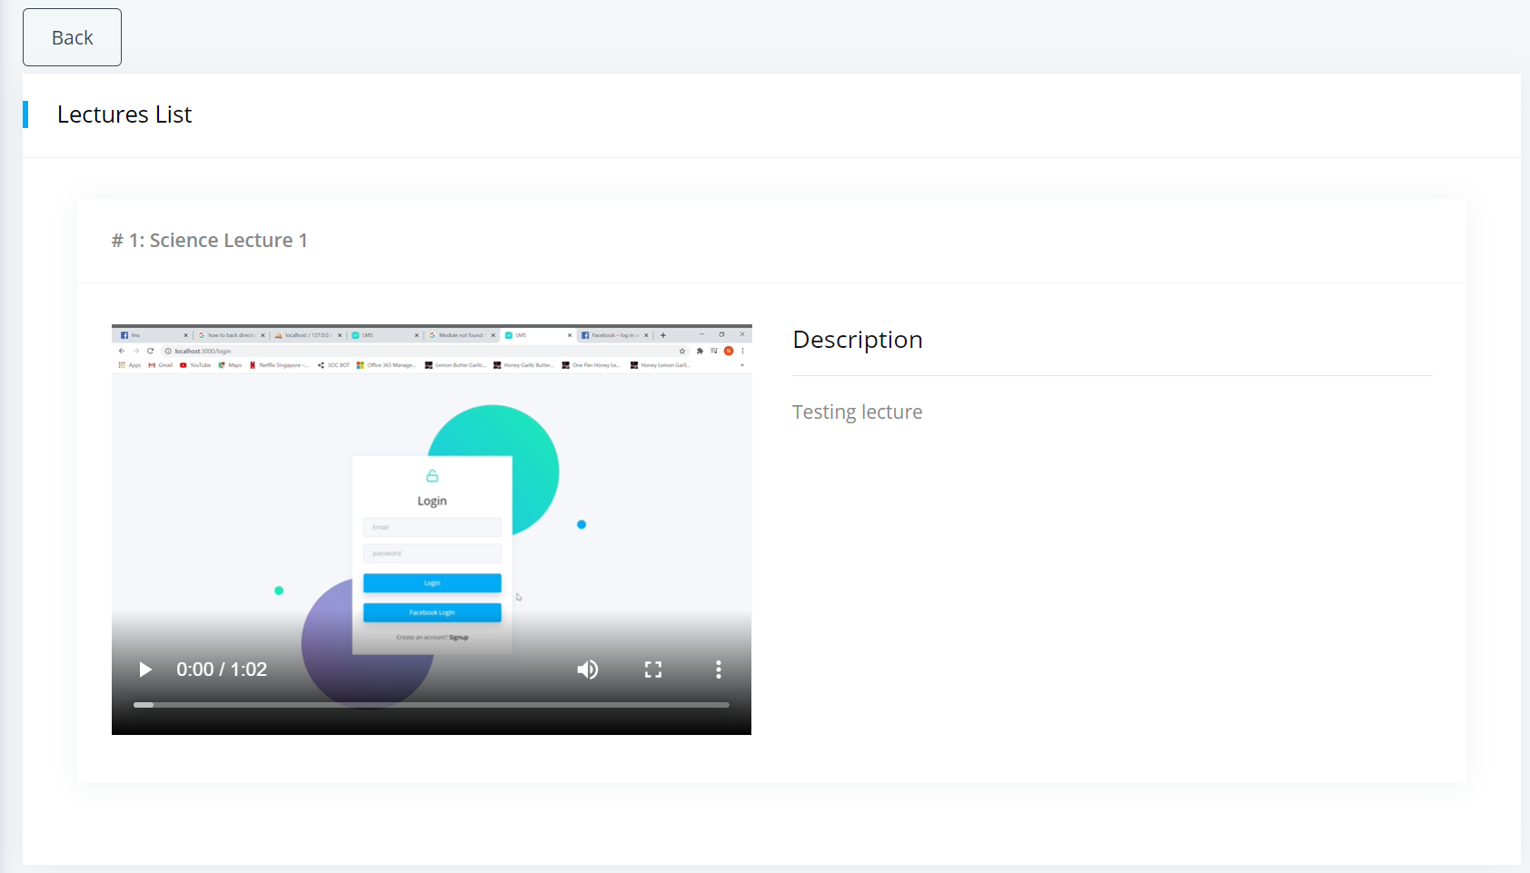

Figure 12: Screenshot of lectures page

Figure 12 shows a screenshot of the lectures page where students can view, or download lectures to view at their own time.

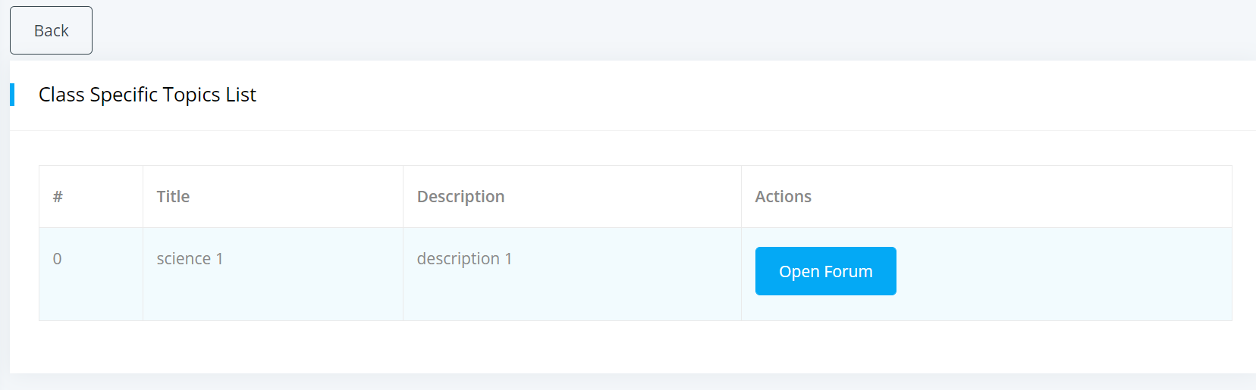

Figure 12: Screenshot of front page of forum page

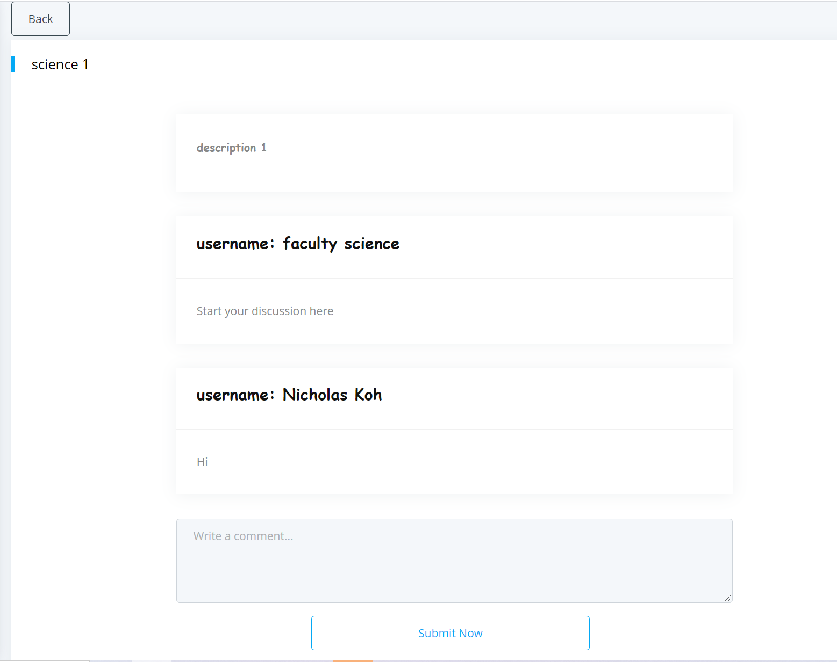

Figure 13: Screenshot of forum discussion page

Figure 12 and 13 shows screenshots of how the forum page will look like where students can engage in discussion with one another.

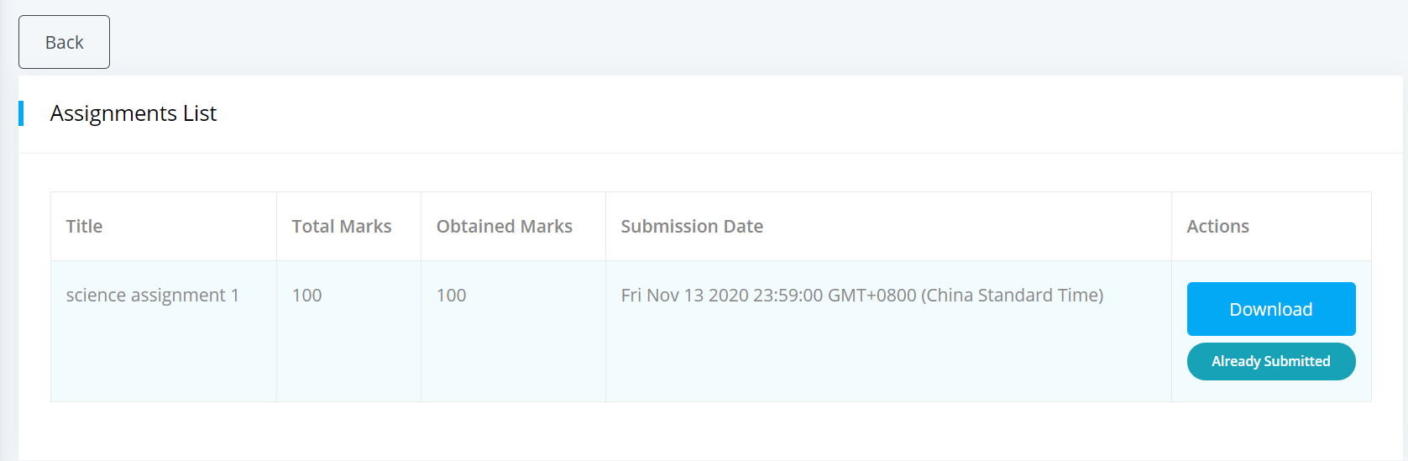

Figure 14: Screenshot of Assignments Page

Figure 14 shows a screenshot of the assignments page where students can view all available assignments/due, check their scores, download and submit their assignments.

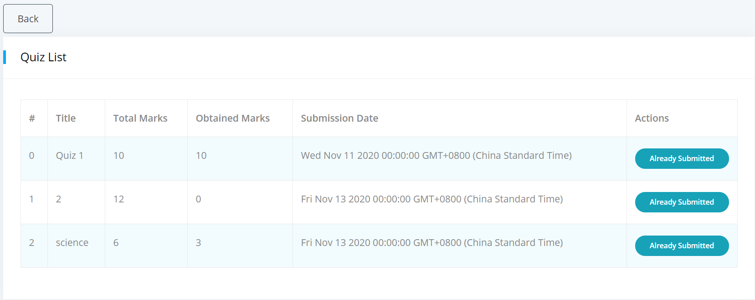

Figure 15: Screenshot of Quizzes Page

Figure 15 shows the screen shot of the quizzes page where students can view available quizzes, submit/ attempt quizzes and check their scores.

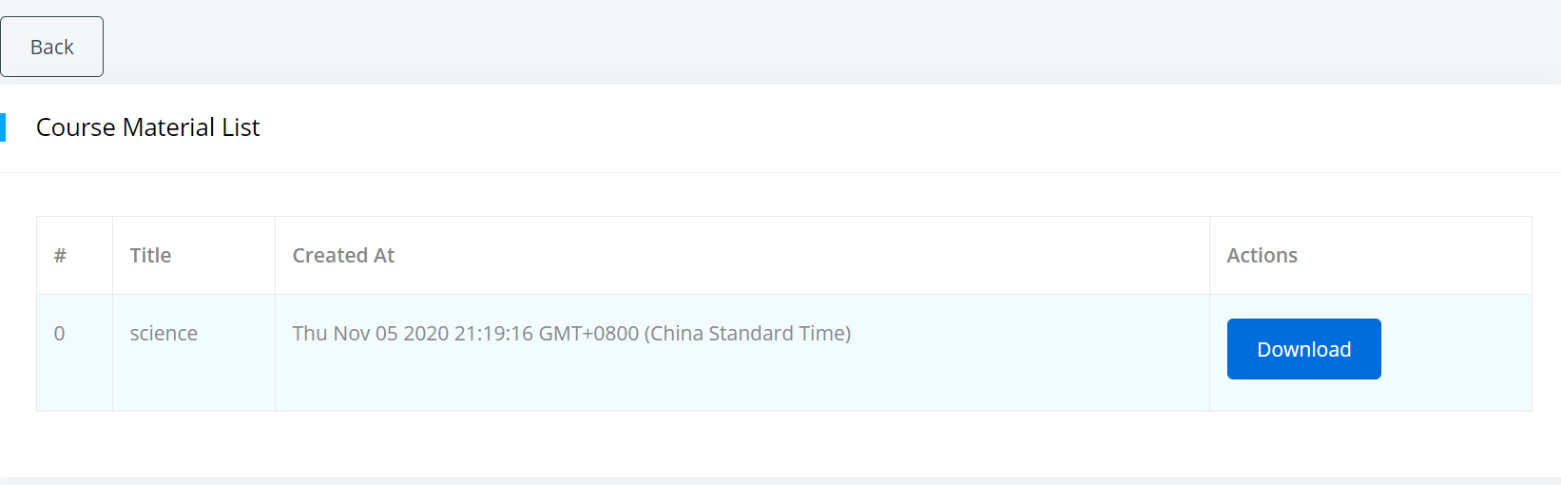

Figure 16: Screenshot of Course Material Page

Figure 16 show the course material page where students can view and download course materials uploaded by the faculty.

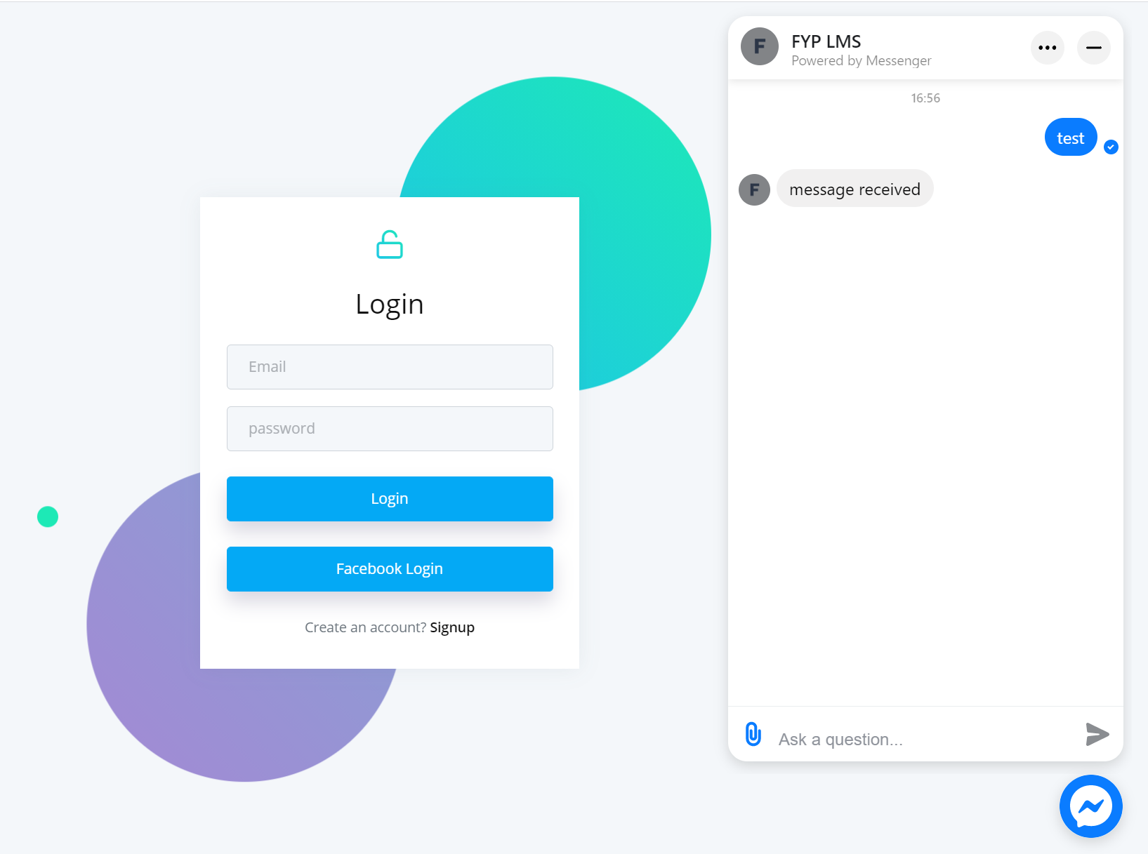

Figure 17: Screenshot of deployed Facebook Messenger

Figure 17 shows the deployment of Facebook messenger where students can communicate with a faculty member that they follow on the LMS directly.

## Faculty View

## Figure 18: Screenshot of Create class page

## Figure 17 shows create class page of the faculty where professors can add a new class to a course.

## Figure 19: Screenshot of Class List

## Figure 18 shows the screenshot of the class list where faculty is able to see the classes that were created and from there, access the other pages associated with the class like “lecture page”, “add assignment”, “Add Quizzes”, etc.

## 

## Figure 20: Screenshot of Enrolled students

## Figure 19 shows the list of enrolled students of a particular class where the faculty is able to see the details of the student. From this page, the faculty is also able to look at the user’s usage patterns and history on the LMS.

## 

## Figure 21: Screenshot of analytics on LMS

## Figure 20 shows a screenshot of some basic analytics running on the LMS which tracks the history of the user’s time on the system to provide some insight to the faculty as to how long each student spends on certain features of the system.

## 

## Figure 22: Screenshot of Progress Page

## Figure 21 shows the progress of an individual student for faculty to keep track of a student’s scores and grades in the semester.

## 

## Figure 23: Screenshot of a typical page for adding materials for a faculty member.

## Faculty member is able to create announcements, create assignments, create quizzes, create discussion topics, and create classes. Therefore, there needs to be a function where faculty members can upload files directly onto the system as shown in Figure 22.

## Admin View

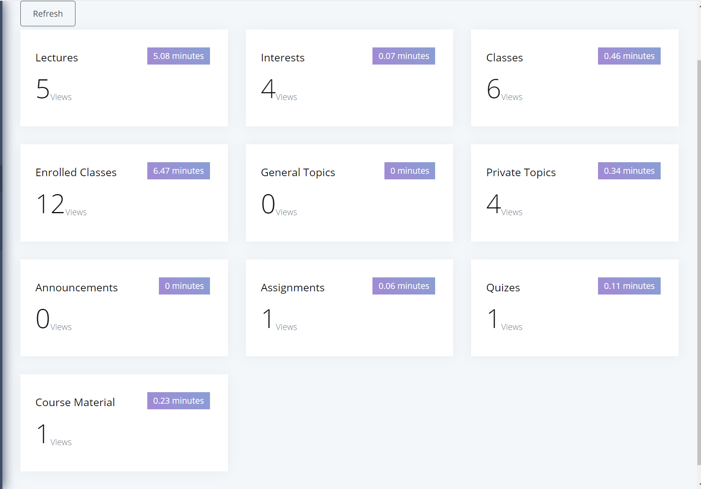

Figure 24: Screenshot of admin dashboard

Figure 23 shows the dashboard for an admin account which shows the usage history of users. This information is used to perform clustering on students to help the school keep track of their progress and identify weaker students.

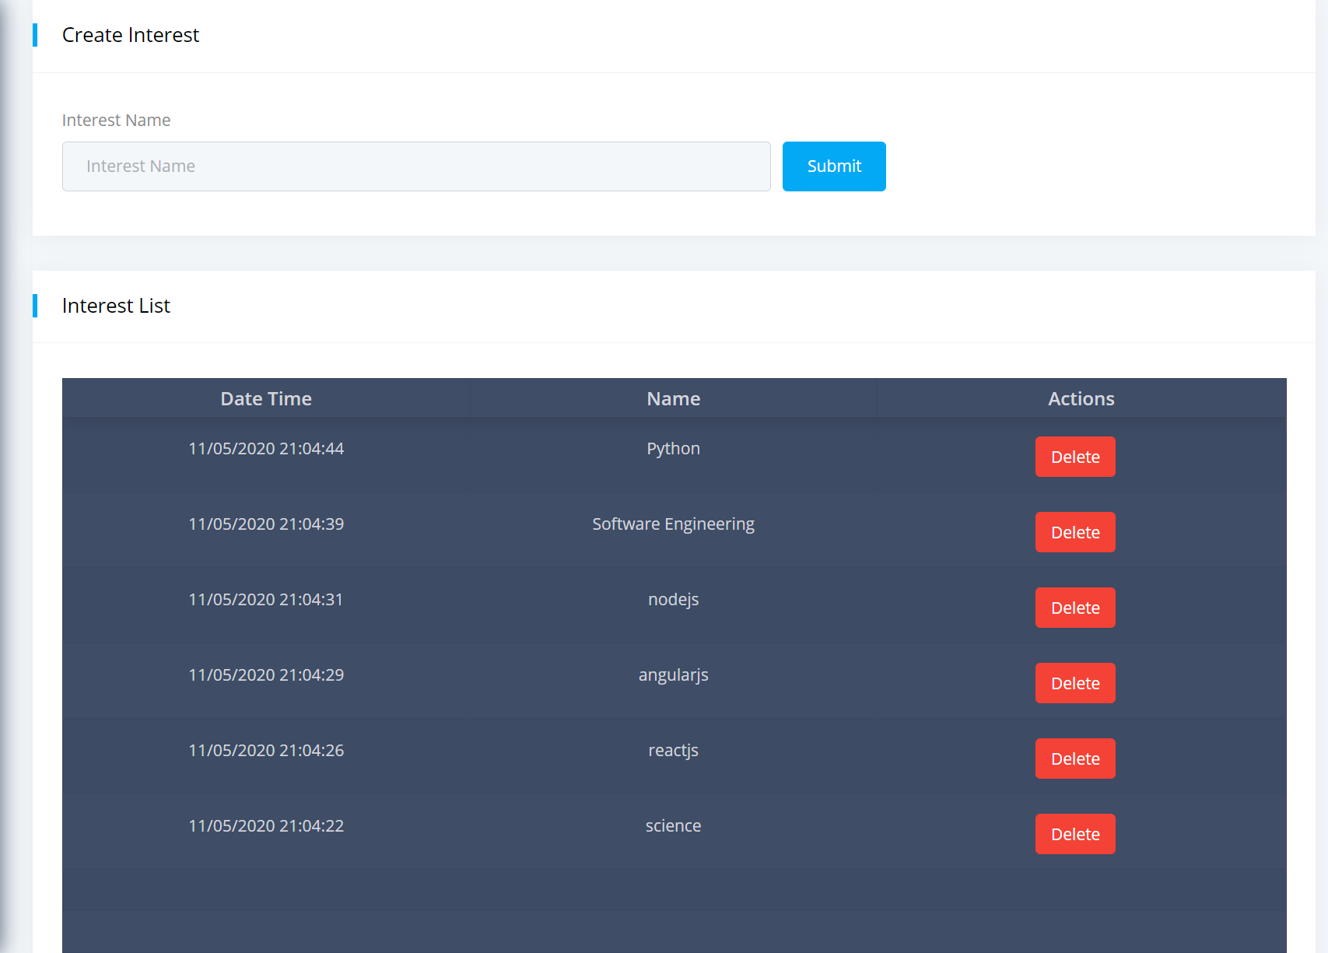

Figure 25: Screenshot of interests list

Figure 24 shows the interested list which can be created by an admin for students to choose from. Having an interest list helps the system identify students with similar interests and therefore in future be able to suggest relevant information to the appropriate students in future.

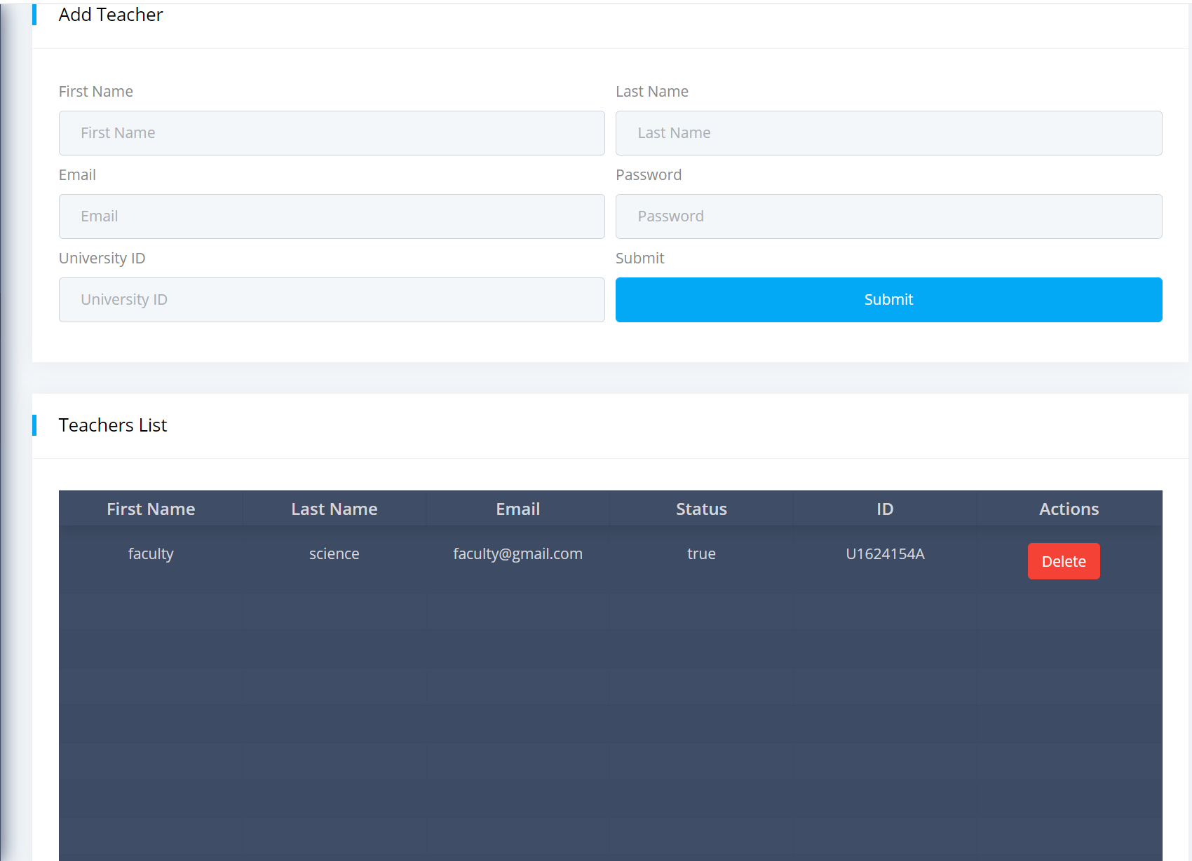

Figure 26: Screenshot of create “Create Teachers” page

Figure 25 shows the “Create Teachers” page where the admin can add new members of faculty onto the system and also view and delete any entries on the same page.

As the endpoint of this project is to potentially make use of analytics to track user behavior and patterns and potentially perform clustering to identify groups of students to better track and provide help to weaker students, a clustering method has been performed on random data set at first to determine if the use of Markov clustering algorithm is plausible for use within the LMS. The algorithm has been written in python due to the ease of coding and the availability of libraries that makes coding quicker and simple. Below is a screenshot of the results of the clustering.

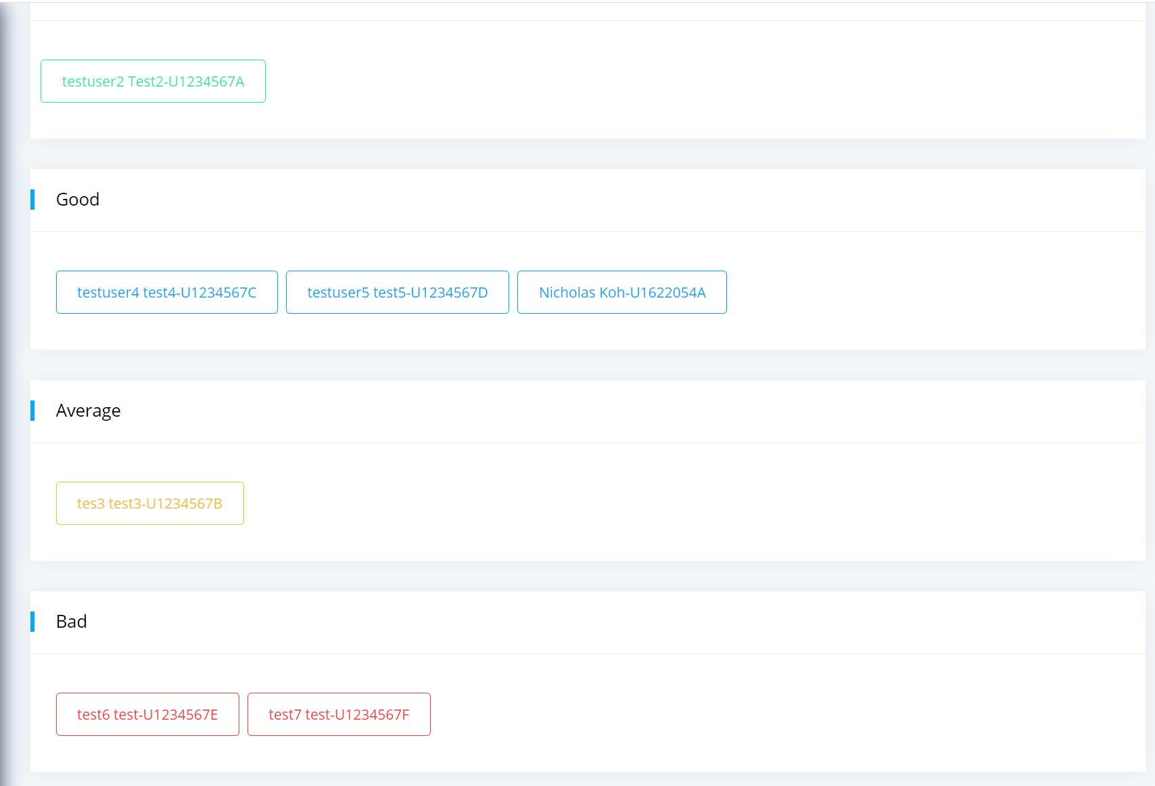

Figure 27: Clustering results after performing k-means

Figure 27 shows the clustering results of students using the LMS platform after performing k-means clustering in the background. K was determined to be 4 for simplicity’s sake to partition the students into 4 different categories based on their user history and patterns. Students who generally spend more time in the LMS platform will be clustered in the group that is on top as shown in the figure while students with little to no user history will be clustered to the group below. This actually provides some insight into how clustering can help faculty identify students who require more attention.

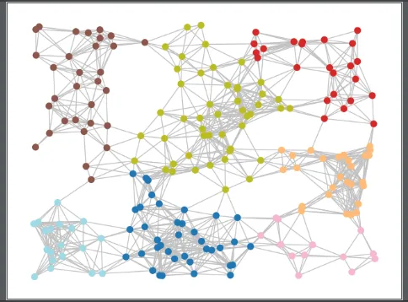

Figure 28: Graph result of initial Markov Clustering

Figure 28 shows that the algorithm works in identifying the different groups in the graph properly. However, there has been an issue in defining what the groups represent and making sense of the results. An attempt was made to try to group students according to their interest specified and their usage history on the LMS. The algorithm was seen to be able to determine different groups of the graph as shown in the figure above with almost little to no bridging nodes between groups meaning that each group might not be that similar from each other. Therefore, this is insightful for the faculty that there is a need to engage the students more that might result in having more interactions between the students and therefore leading to more connecting/ bridging nodes between each group.

# Conclusion

There has been an attempt to create a new LMS with the benefits of analytics and clustering algorithm to identify groups of students within the university network. While it has been shown that the usage of markov clustering is helping in identifying different groups within the network more work still need to be done to better define the meaning of the different groups and how any user can make sense of the results available to them. There needs to be more work done also to come up with a fool-proof method to measure the effectiveness of the LMS in terms of whether it will provide students a good platform for learning and helping them retain knowledge better. The use of certain features like forum discussion promote small group discussions among students which might be able to help refresh their memory when they engage in these discussions.

The use of social media is also to help ease the facilitation of logins and make use of Facebook to keep students and faculty connected. The use of messenger means students can easily contact faculty members or engage in group discussion among themselves which was not available in blackboard and other LMS platforms.

# References

[1]

1. *WHO declares Covid-19 outbreak a pandemic*. (2020, March 12). The Straits Times. <https://www.straitstimes.com/singapore/who-declares-covid-19-outbreak-a-pandemic>

   Sociological Science. (2020, May 27). *The Small-World Network of College Classes: Implications for Epidemic Spread on a University Campus*. <https://sociologicalscience.com/articles-v7-9-222/>

   UNESCO. (2020, September 08). *Education: From disruption to recovery.* <https://en.unesco.org/covid19/educationresponse>

   Urdan, T.A(2000). *Corporate E-learning: Exploring a New Frontier.* W.R. Hambrecht, 2000

   Active Learning | Center for Educational Innovation. Active Learning. <https://cei.umn.edu/active-learning>. Accessed 10 Dec 2020

   What is Active Learning. <https://www.queensu.ca/teachingandlearning/modules/active/04_what_is_active_learning.html>. Accessed 10 Dec 2020.

   Active Learning Activities. (March 04, 2019). Centre for Teaching Excellence.   
   <https://uwaterloo.ca/centre-for-teaching-excellence/teaching-resources/teaching-tips/developing-assignments/assignment-design/active-learning-activities>

   Dwyer, Catherine; Hiltz, Starr Roxanne; and Passerini, Katia, "Trust and Privacy Concern Within Social Networking Sites: A Comparison of Facebook and MySpace" (2007). AMCIS 2007 Proceedings. 339.  
   <https://aisel.aisnet.org/amcis2007/339>

   Selwyn, Neil. “Faceworking: exploring students' education‐related use of Facebook.” Learning, Media and Technology 34 (2009): 157 - 174.)

   Madge, C., Meek, J., Wellens, J. & Hooley, T. (2009). “Facebook, social integration and informal learning at university: it is more for socialising and talking to friends about work than for actually doing work”. Learning, Media and Technology, 34, 2, 141–155.

   Using Social Media for Learning. (2020, Apr 03). The University of Arizona Global Campus. <https://www.ashford.edu/blog/online-learning/using-social-media-as-a-learning-tool>

   The Psychology of Social Media. King University Online. <https://online.king.edu/news/psychology-of-social-media/>. Accessed 10 Dec 2020.

   Taylor, J. E., & Ku, H.-Y. (2011). Measuring active learning to predict course quality. Performance Improvement Quarterly, 24(1), 31–48. doi:10.1002/piq.20104

   Van Amburgh, J. A., Devlin, J. W., Kirwin, J. L., & Qualters, D. M. (2007). A tool for measuring active learning in the classroom. American journal of pharmaceutical education, 71(5), 85. <https://doi.org/10.5688/aj710585>

   Alfred P. Rovai( 2002). “Sense of community, perceived cognitive learning, and

   persistence in asynchronous learning networks”. Regent University.

   Hasegawa, Shinobu & Ochimizu, K.. (2005). A learning management system based on the life cycle management model of e-learning courseware. 35 - 37. 10.1109/ICALT.2005.11.)

   Valsamidis, Stavros & Kontogiannis, S. & Kazanidis, Ioannis & Theodosiou, Theodosios & Karakos, Alexandros. (2012). A Clustering Methodology of Web Log Data for Learning Management Systems. Educational Technology and Society. 15

   Steinley, D., & Brusco, M. J. (2007). Initializing K-means Batch Clustering: A Critical Evaluation of Several Techniques. Journal of Classification, 24(1), 99–121. doi:10.1007/s00357-007-0003-0

   Dr. Michael J. Garbade, Understanding K-means Clustering in Machine learning( Accessed 14 Dec 2020), https://towardsdatascience.com/understanding-k-means-clustering-in-machine-learning-6a6e67336aa1